Product Requirements
Project: Locate A Doctor
Team: Team 8

Revision History

Date | Version | Description | Author
02-03-2024 | 1.0 | Outline of the project | Rohan varma Bandari, Sai kumar Reddy Barda, Ravi kiran Reddy Sabbireddy, Vinay kumar Shetty.
02-04-2024 | 1.1 | Problem Statement | Ravi Kiran Reddy Sabbireddy
02-05-2024 | 1.2 | Stakeholders, Software Requirements | Rohan Varma Bandari, Vinay kumar shetty
02-06-2024 | 1.3 | Functional Requirements. (1-6) | Sai kumar Reddy Barda
02-06-2024 | 1.4 | Functional Requirements. (7-12) | Vinay kumar Shetty
02-06-2024 | 1.5 | Functional Requirements. (13-15) | Rohan varma Bandari, Sai kumar Reddy Barda, Ravi kiran Reddy Sabbireddy, Vinay kumar Shetty
02-07-2024 | 1.6 | Non-Functional Requirements | Rohan Varma Bandari
02-08-2024 | 1.7 | Use Case Diagram | Ravi Kiran Reddy Sabbireddy,
02-08-2024 | 1.8 | Use Case Description (1-3) | Sai kumar Reddy Barda
02-08-2024 | 1.9 | Use Case Description (4-8) | Rohan Varma Bandari
02-09-2024 | 1.10 | Use Case Description (9-12) | Vinay kumar Shetty
02-10-2024 | 1.11 | Use Case Description (13-15) | Ravi Kiran Reddy Sabbireddy
02-11-2024 | 1.12 | Individual Contribution and Document editing. | Rohan varma Bandari, Sai kumar Reddy Barda, Ravi kiran Reddy Sabbireddy, Vinay kumar Shetty

Brief problem statement

Locate A Doctor, aims to revolutionize healthcare by providing a comprehensive solution for patients, doctors, and administrators. With a focus on accessibility, efficiency, and accuracy, the system addresses the complexities of healthcare management in today's digital age. In the current healthcare landscape, there exists a significant gap between patient needs and healthcare services. Patients often face challenges in accessing timely and accurate medical care, while healthcare providers struggle with inefficient appointment scheduling and resource allocation. Additionally, administrative tasks are often cumbersome and prone to errors, leading to delays and inefficiencies in hospital operations. The Locate a doctor seeks to address these challenges by providing a user-friendly, web-based platform that streamlines the entire healthcare process. By integrating advanced symptom analysis, disease prediction algorithms, and doctor availability data, the system empowers patients to make informed decisions about their health and easily connect with suitable healthcare providers.
Key Objectives:
- Enable patients to input their symptoms and receive accurate predictions of possible diseases, along with recommended precautions.
- Categorize patients based on their predicted diseases and recommend appropriate categories of doctors for consultation.
- Utilize pin code information to fetch doctors available in the patient's area, ensuring accessibility to healthcare services.
- Facilitate easy appointment scheduling with chosen doctors, optimizing the patient experience and reducing waiting times.
- Implement robust appointment management functionalities for doctors and administrators, including scheduling, rescheduling, cancellation, and reminders.

The project will be a web-based platform that enables healthcare professionals and patients to access patient data, schedule appointments, manage medical records, receive medical guidance.

Stakeholders

“Locate A Doctor” Team - Investor and Board of Directors

“Locate a doctor” team is funding this project. The investors actively participate in crucial project deliberations, where both the investors and the Board of Directors assess the project's scope, user base, and necessary resources for funding across its various phases.

“University of North Texas” Staff - Product owner

Dr. Wajdi Aljedaani and the accompanying staff will function as the product owners, taking responsibility for conceptualizing the project and effectively conveying their vision to the development team. Below are some of the product owner responsibilities:

● Guides the project/product.

● Allocates resources.

● Backing for the product.

● Supervising stakeholders.

Patients
Patients are the primary users of the system. They rely on the system to access healthcare services efficiently, including symptom analysis, disease prediction, doctor consultation, and appointment booking. Patients expect the system to be user-friendly, reliable, and capable of addressing their healthcare needs effectively.

Doctors and Healthcare Providers
Doctors and healthcare providers utilize the system to manage patient appointments, review medical history and symptoms, diagnose diseases, and provide medical care. They expect the system to streamline workflow, optimize patient scheduling, and facilitate effective communication with patients.

Insurance Companies
Insurance companies play a role in the reimbursement and payment process for healthcare services. They may interface with the system to verify patient eligibility, process claims, and facilitate payment transactions. Insurance companies expect the system to accurately record and track patient data, support efficient claims processing, and ensure compliance with regulatory standards.

Patient’s Families and Caregivers
Patients' families and caregivers may interact with the system on behalf of the patient. They expect the system to facilitate communication, provide access to relevant medical information, and support their role in the patient's care journey.

Software Engineering Team
- The software engineering team plays a crucial role in overseeing and advancing the project life cycle. Their duties encompass:
- Defining the project requirements.
- Executing the project and its functionalities.
- Performing software testing.
- Breaking down the project into tasks and distributing them among team members.

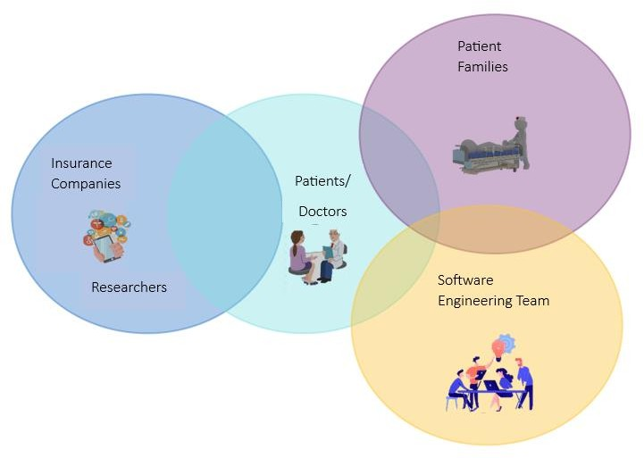
Fig.1 Stakeholders relation

System requirement

The Locate Doctor, Smart Health will consist of a centralized web-based application with the following system requirements:
- The project shall use JavaScript as the primary programming language for frontend and backend development.
- The project shall utilize React version 17.0.2 as the front-end framework for building interactive user interfaces.
- The project shall integrate with a MySQL cloud database for efficient storage and management of patient data, doctor profiles, appointments, and other relevant information.
- The project shall be designed to be compatible with the most recent versions of popular web browsers such as Google Chrome, Mozilla Firefox, Safari, and Microsoft Edge to ensure optimal performance and user experience for all users accessing the system.

Feature requirements

- Functional
No. | User Story Name | Description | Release
1 | User Registration | Patients and doctors shall be able to register accounts with the system. | R1
2 | User Login | Registered users shall be able to log in securely using their credentials. | R1

3 | Symptom Input | Patients shall be able to input their symptoms into the system for analysis. | R1
4 | Disease Prediction | The system shall analyze symptoms and  predict possible diseases based on established medical knowledge. | R1
5 | Precaution  Recommendations | After predicting diseases, the system shall provide recommended precautions for patients to follow. | R1
6 | Doctor Categorization | Based on predicted diseases, the system shall categorize patients and recommend appropriate doctors. | R1
7 | Doctor Search | Patients shall be able to search for doctors based on specialty, location, and availability. | R1
8 | Appointment Booking | Patients shall be able to book appointments with doctors through the system. | R1
9 | Appointment Management | Doctors and patients shall be able to manage their appointments, including scheduling,  rescheduling, and cancelling. | R1
10 | Patient Record Management | Doctors and patients shall be able to access and update patient records, including medical history and prescriptions. | R1
11 | Dashboard | Administrators shall have access to a dashboard to monitor system activities, manage user accounts, and generate reports. Doctors and patients also access the dashboard. | R1
12 | Manage Doctor | The system shall manage the doctor profiles. | R1
13 | Feedback | Users shall be able to provide feedback on their experience with the system, allowing for continuous improvement. | R1

14 | Reports | The system shall generate comprehensive reports on various metrics such as appointment bookings and patient  demographics. | R1
15 | Trend Analysis | The system shall be able to analyze trends in patient symptoms, diseases, and appointment bookings. | R1

Non-Functional

Security
User data shall be encrypted during transmission and storage to prevent unauthorized access.

Usability
The user interface shall be intuitive and user-friendly, requiring minimal training for users.

Accessibility
The system shall be available 24/7, with provisions for scheduled maintenance and backup procedures.

Use case diagram
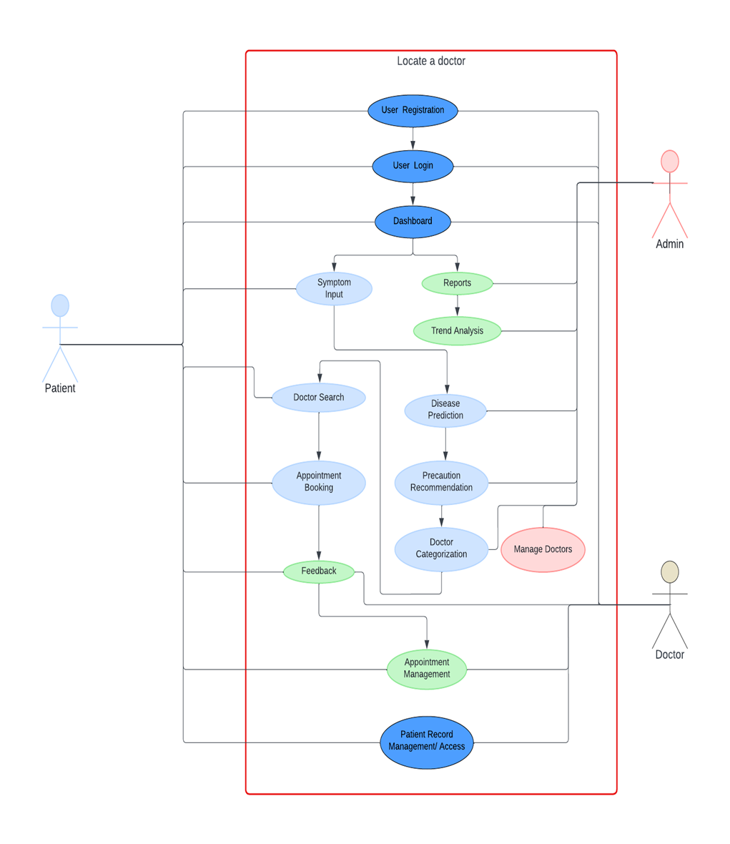

Fig.2 Use Case Diagram.

Use case description

Use Case Number | UC-01
Use Case Name | User Registration
Overview | This use case involves the registration of a new user in the system, enabling them to create an account.
Actor(s) | Patient, Doctor
Pre-condition(s) | - The portal has been set up, running, and configured.  - Registrant has accessed the portal through URL.
Scenario Flow | - Users shall be asked for registration page.  - The system shall respond with the registration questions.  - Users shall be able to fill out the registration form with required details and submit it.  - UserName  - Address  - Password  - EmailID  - The system shall validate the information and create a new user account.
Alternate Flows | If the provided username is already taken, the system prompts the user to choose a different username.
Post Condition | User’s account is successfully registered, and they can now log in to the system.

Use Case Number | UC-02
Use Case Name | User Login
Overview | This use case involves users logging into the system using their credentials.

Actor(s) | Patient, Doctor
Pre-condition(s) | Registered user account exists.
Scenario Flow | - Users shall navigate to the login page.  - The system shall respond to the user by requesting login details.  - Username  - password  - Users shall enter their username and password and click on the login form.  - The system shall verify the credentials and grant access to the user.  - If the entered credentials are invalid, the system displays an error message and prompts the user to re-enter their credentials and start from step 1.  - User is directed to the dashboard page
Alternate Flows | Not applicable.
Post Condition | User is successfully logged into the system and directed to their respective dashboard.

Use Case Number | UC-03
Use Case Name | Symptom Input
Overview | This use case involves user inputting their symptoms into the system for disease prediction.
Actor(s) | Patient
Pre-condition(s) | user is logged into the system.
Scenario Flow | - Users shall be able to access the symptom input section.  - The system shall provide a form of symptom details.  - Users shall be able to enter their symptoms into the provided form and submit the symptom data.  - The system shall process the symptoms for disease prediction.  - User shall be able to redirected to disease prediction page

Alternate Flows | Not Applicable
Post Condition | Symptom data is successfully processed for disease prediction.

Use Case Number | UC-04
Use Case Name | Disease Prediction
Overview | This use case involves predicting possible diseases based on the symptoms entered by the user.
Actor(s) | Admin
Pre-condition(s) | Symptom data is available in the system.
Scenario Flow | - User accesses the disease prediction section where User inputs the symptom data for analysis  - System predicts potential diseases based on the analyzed symptoms.  - User shall be able to redirected to precautions recommendation page.
Alternate Flows | Not Applicable.
Post Condition | System provides a predicted disease for further action.

Use Case Number | UC-05
Use Case Name | Precaution Recommendations

Overview | This use case involves recommending precautions to the user based on the predicted diseases.
Actor(s) | Admin
Pre-condition(s) | Predicted diseases are available.
Scenario Flow | - User accesses the precaution recommendation section and views the predicted disease.  - System generates and presents recommended precautions for disease.  - User shall be able to redirect to doctor categorization.
Alternate Flows | Not Applicable.
Post Condition | user is provided with recommended precautions for the predicted diseases.

Use Case Number | UC-06
Use Case Name | Doctor Categorization
Overview | This use case involves categorizing doctors based on the predicted diseases.
Actor(s) | Admin
Pre-condition(s) | Predicted diseases are available.
Scenario Flow | - User accesses the doctor categorization section and views the list of predicted diseases.  - System categorizes doctors into relevant specialties based on the predicted diseases.  - User shall be redirected to doctor search.

Alternate Flows | Not Applicable
Post Condition | System provides a list of categorized doctors for user consultation.

Use Case Number | UC-07
Use Case Name | Doctor Search
Overview | This use case involves user searching for doctors based on their categorized specialties.
Actor(s) | Patient
Pre-condition(s) | Categorized doctors shall be available in the system.
Scenario Flow | - Users shall access the doctor search section.  - The system shall ask for the specialty category.  - Users shall select a specialty category.  - The system shall provide the list of doctors available in the selected category.  - User can select the specified doctor and shall be able to redirect to the appointment booking.
Alternate Flows | Not Applicable
Post Condition | User can view the list of doctors available in the selected specialty category for consultation.

Use Case Number | UC-08
Use Case Name | Appointment Booking

Overview | This use case involves user booking appointments with selected doctors.
Actor(s) | Patient
Pre-condition(s) | User is logged into the system, and doctor availability is known.
Scenario Flow | - User accesses the appointment booking section and selects a doctor for consultation.  - System provide the details of date and time for appointments.  - User selects an available date and time for the appointment and confirms the appointment booking.  - System shall redirect the user to feedback page.
Alternate Flows | Not Applicable.
Post Condition | Appointment is successfully booked, and confirmation details are provided to the user.

Use Case Number | UC-09
Use Case Name | Appointment Management
Overview | This use case involves managing appointments by doctors and Patients.
Actor(s) | Patient, Doctor
Pre-condition(s) | Appointments exist in the system.
Scenario Flow | - User accesses the appointment management section.  - System shows the booked appointments.

3. User manages appointments by
rescheduling, cancelling, or confirming them.
Alternate Flows | Not Applicable
Post Condition | Appointments are successfully managed according to the actions taken by the Users.

Use Case Number | UC-10
Use Case Name | Patient Record Management
Overview | This use case involves managing patient records by doctors and administrators.
Actor(s) | Doctor, Patient
Pre-condition(s) | User records exist in the system.
Scenario Flow | - User accesses the patient record management section.  - System shows the patient records.  - Users can view, update, or delete patient records as necessary.  - The system will update the changes according to user requirements.
Alternate Flows | Not Applicable
Post Condition | user records are successfully managed according to the actions taken by the doctor/patient.

Use Case Number | UC-11
Use Case Name | Dashboard
Overview | This use case involves users accessing their respective dashboards for managing their functionalities.
Actor(s) | Patient, Doctor
Pre-condition(s) | User is logged into the system.
Scenario Flow | - User accesses their dashboard after successful login.  - System shows available functionalities such as symptom input, appointment booking, and patient record management.  - User shall be able to access each functionalities and proceed according to his requirements.
Alternate Flows | Not Applicable
Post Condition | User can effectively manage their functionalities from the dashboard.

Use Case Number | UC-12
Use Case Name | Feedback
Overview | This use case involves users providing feedback to the system for improvement.
Actor(s) | Patient, Doctor

Pre-condition(s) | User interaction with the system.
Scenario Flow | - User accesses the feedback section.  - System shall ask for feedback details.  - User provides feedback regarding their experience, suggestions, or concerns and submits their feedback.
Alternate Flows | Not Applicable
Post Condition | Feedback is successfully submitted to the system for review and improvement.

Use Case Number | UC-13
Use Case Name | Reports
Overview | This use case involves generating reports based on system data for analysis or documentation purposes.
Actor(s) | Admin
Pre-condition(s) | Relevant data exists in the system.
Scenario Flow | - User accesses the reporting system and selects the parameters and criteria for the report.`  - System generates the report based on the specified criteria.
Alternate Flows | Not Applicable

Post Condition | Report is successfully generated and available for analysis or documentation.

Use Case Number | UC-14
Use Case Name | Trend Analysis
Overview | This use case involves analyzing trends in system data for identifying patterns or insights.
Actor(s) | Admin
Pre-condition(s) | Relevant data exists in the system.
Scenario Flow | - User accesses the trend analysis section.  - System provide the option to select the parameters.  - User selects the data and parameters for analysis.  - System performs trend analysis and generates insights.
Alternate Flows | Not Applicable
Post Condition | Trends and insights are successfully generated based on the analysis.

Individual Contributions:

Student Name | Student-ID | Contributions
Rohan Varma Bandari | 11702063 | Worked on software requirements, Functional requirements (13-15), Non-functional requirements, Use case description (4-8).
Sai Kumar Reddy Barda | 11698748 | Worked on Functional requirements (1-6), (13-15), use case description (1-3).
Ravi Kiran Reddy Sabbireddy | 11699464 | Worked on Problem Statement, Functional requirements (13-15), Use case diagram, Use case description (13-15).
Vinay Kumar Shetty | 11700128 | Worked on stakeholders, Functional requirements (7-12), (13-15), Use case description (9-12).

